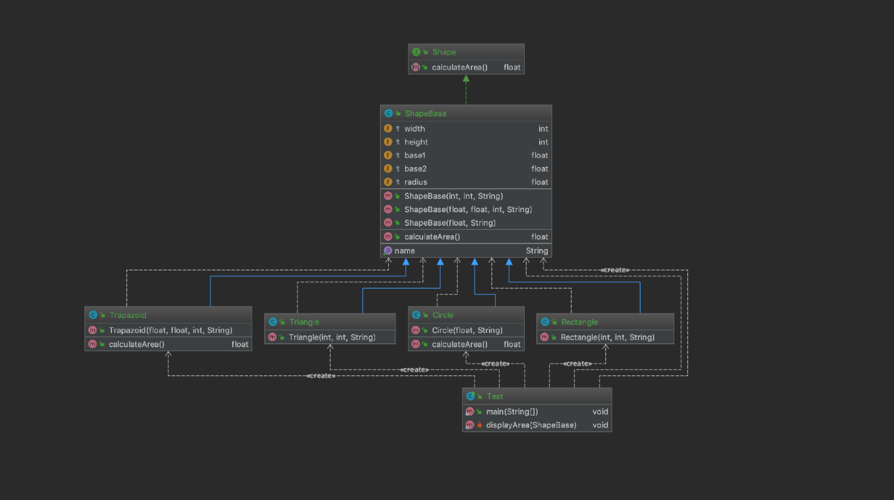

Polymorphism is demonstrated in this activity by having multiple shapes that extend the parent class of BaseShape. While most shapes will work with the standard constructer, shapes with angles like circles or irregular shapes like trapezoids require a few more parameters to find the area. You can easily create custom constructors for the shapes you need and inherit properties that are already present and don’t need to be defined again, like Height that was used in the trapezoid calculation. This allows the child classes to use and change what they need to make the class work for their needs without changing the base class/constructor.